prepare employee excel

3343 Tiya Tom 43434

2232 ken binoy 12345

1231 jia jom 45454

prepare emp table

SAL NUMBER(7,2) Yes 3

ENAME VARCHAR2(20 BYTE) Yes 2

EMPNO NUMBER(4,0) No 1

1234 Smitha Jac 42000

1235 Alex Johan Fernandez 48050.5

136 Tom smith 44444

1265 llen Ken 34560

right click on emp table and import data

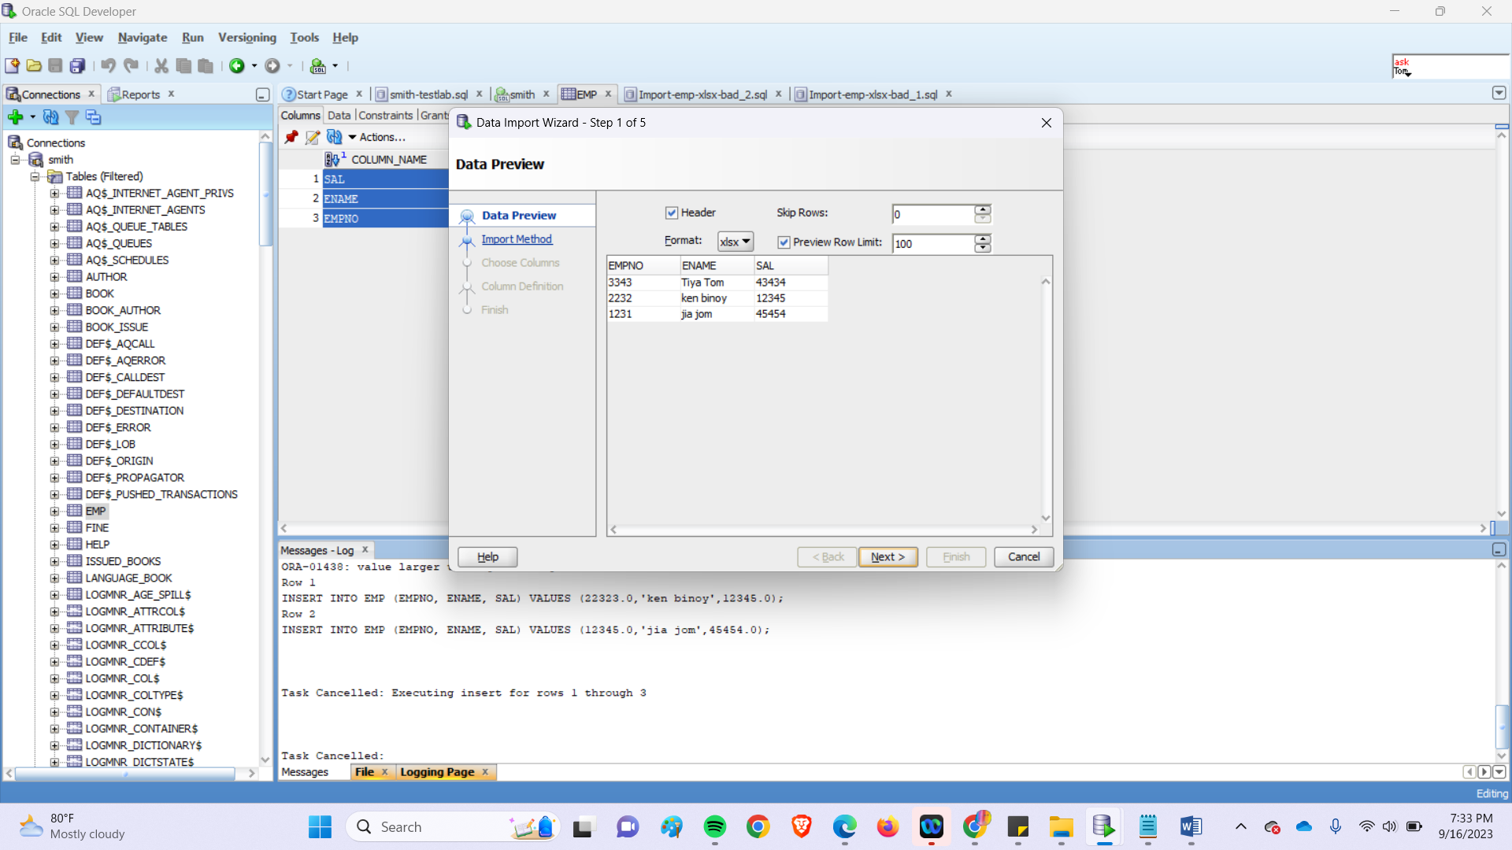

Match all fields

Click finish..data will be imported

EXPORT

